Module 8

Assignment 8.2
Course: CSD420-340A Advanced Java for Programmers
Prepared By: Mirach Erkol
Date of Report: 5/3/2026

https://github.com/Mikey5007/csd-420.git

8.2 Assignment: Running in PowerShell

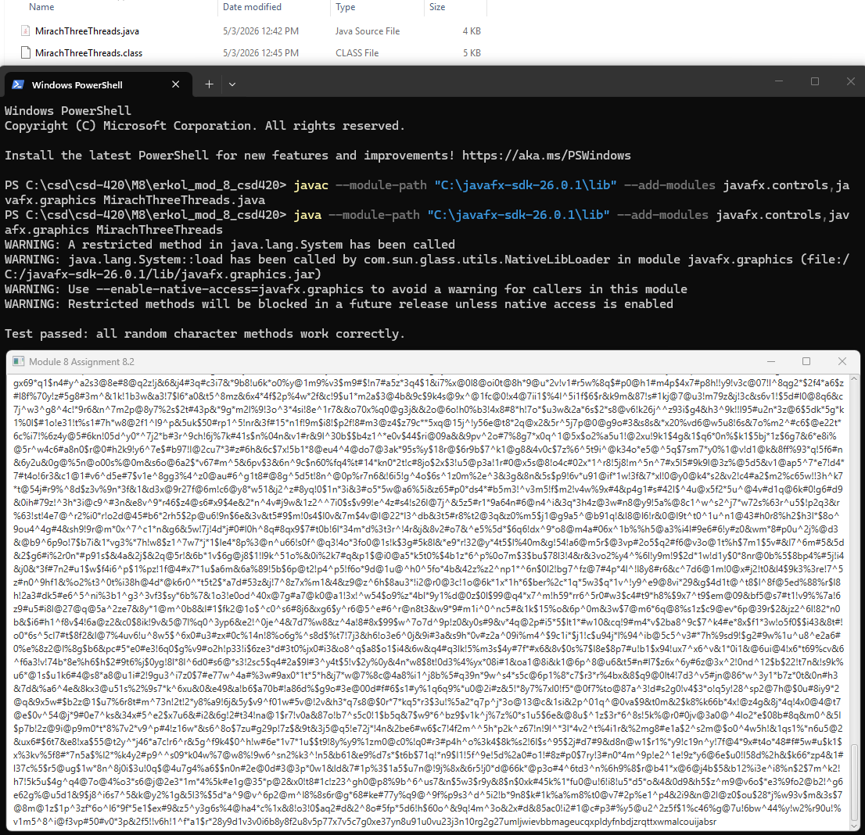

References:

https://github.com/Mikey5007/csd-420.git

